GROUP A (Candy Capilla, Essi Monneus, Max Browning)

1/16/2021

# Overview

## Project Background and Description

Music is a universal language that is withstood the test of time and is present in nearly all areas of the globe. Spotify is one of the top music platforms in the U.S. One thing that is always interested me about music is how different the songs on the top of charts are; when I listen to Spotify’s top 50, I can expect to hear anything from pop to country or from rap to children within the span of 15 minutes. We choose this topic because There is a strong interest in music in our team.

## Dataset: https://www.kaggle.com/yamaerenay/spotify-dataset-19212020-160k-tracks?select=data_by_genres.csv

● 160,000+ songs with 19 data points each

● Good combination of qualitative points, binary options, and number ranges

● Also includes slimmed down version grouped by artists, genre, or year

## Inspiration Screenshots:

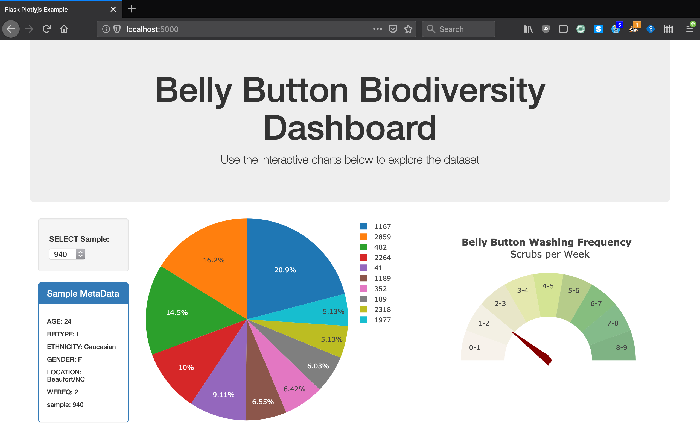

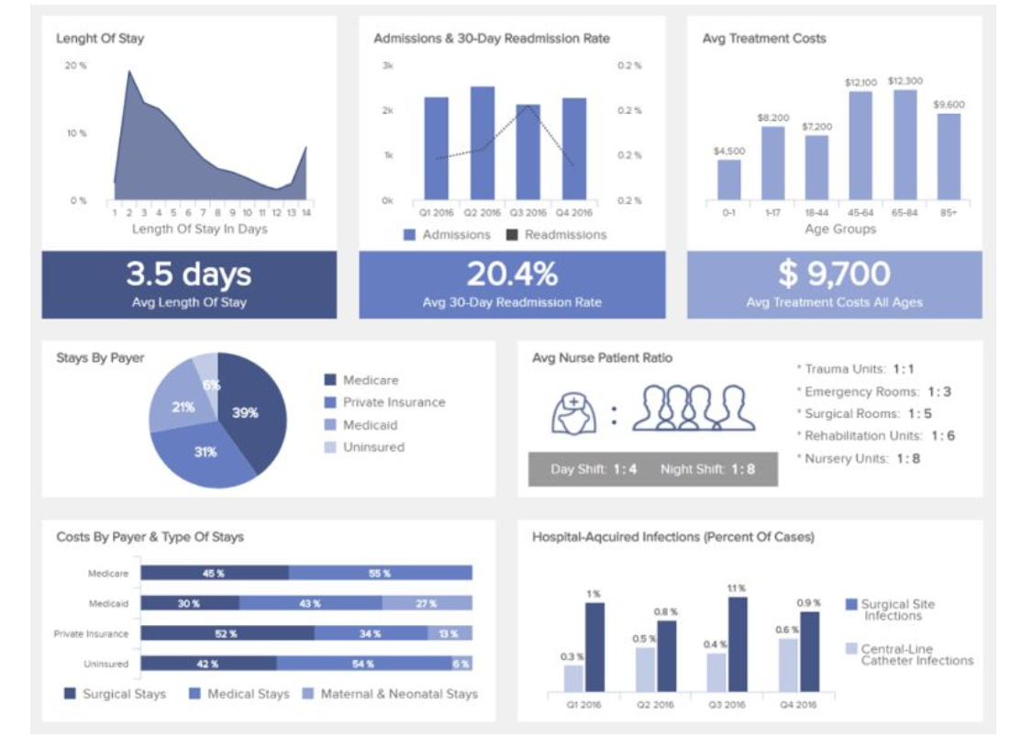

## Sketch

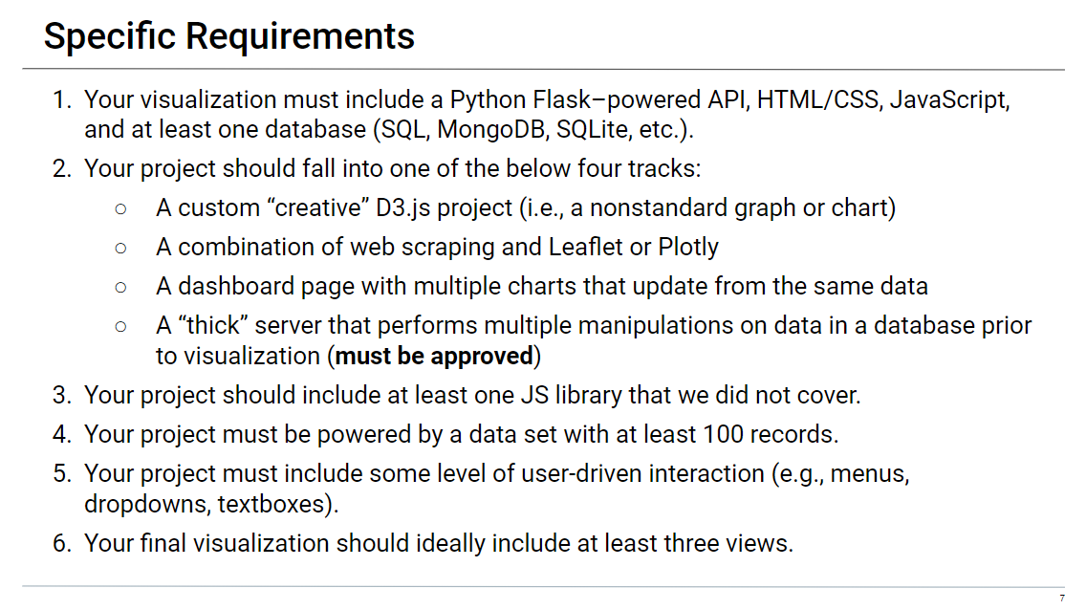

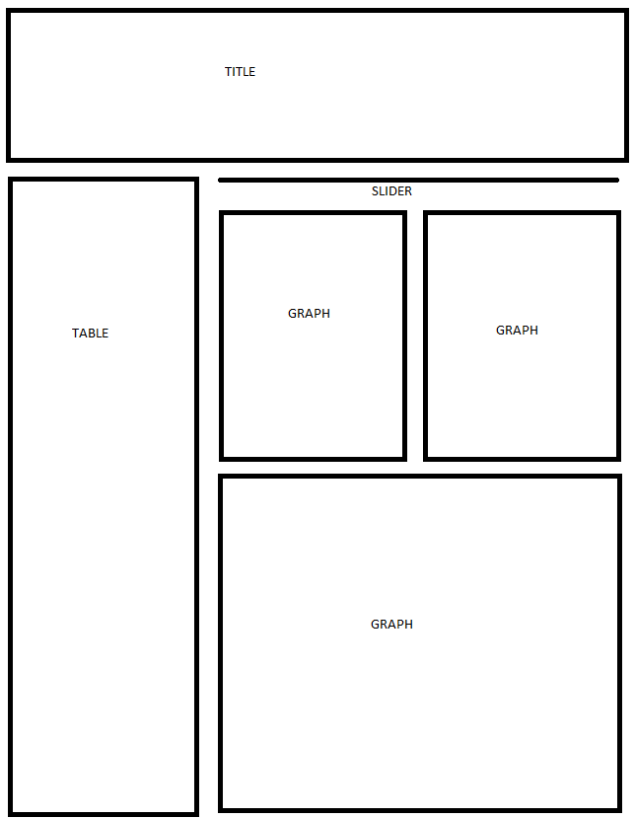

## Link to GitHub Repo

https://github.com/Candy-Capilla/Spotify_project_G1

## Metadata

Source: Spotify Web API

The original data contains songs from 1920 to 2020.

Data: 2000 – 2020

Columns:

* Valence
* year
* decade
* acousticness
* artists
* danceability
* duration_ms
* energy
* explicit
* instrumentalness
* key
* liveness loudness
* mode
* name
* popularity
* speechiness
* tempo